C7_5

setwd(".")  
library(knitr)  
  
x<-seq(0,12000,10)  
n<-12  
x1<-36300  
x2<-38100  
s1<-5000  
s2<-6100  
Alfa<-1-0.95

Apartados a) y b)

y<-dnorm(x, x2-x1, sqrt((s1^2/n)+(s2^2/n)))  
plot(x,y, type = "l", col="red", lwd=2, ylab = "Densidad de Probabilidad", xlab =  
 "Diferencia de Medias", main ="Analisis Grafico");   
grid()  
xliminf<-qnorm(Alfa/2, x2-x1, sqrt((s1^2/n)+(s2^2/n)))  
xlimsup<-qnorm(1-Alfa/2, x2-x1, sqrt((s1^2/n)+(s2^2/n)))  
xliminf

## [1] -2662.596

xlimsup

## [1] 6262.596

xv<-x[x>=xliminf & x<=xlimsup]  
yv<-y[x>=xliminf & x<=xlimsup]  
xv<-c(xv,xlimsup,xliminf)  
yv<-c(yv,y[1],y[1])  
polygon(xv,yv,col="orange", density=25, border="black")

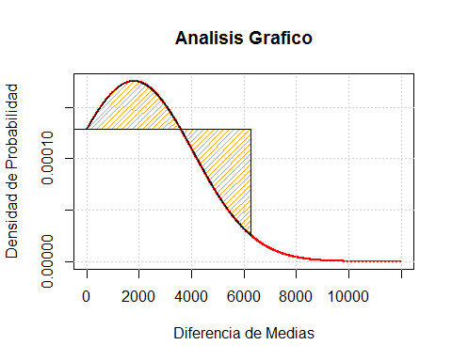

Conclusiones